Project Synopsis

 | Title of the Project | Document Verification and Authentication.
 | Users of the System | Passport office,colleges,pan card office,any organizations,which gives Identity Card to their employee.
 | Existing System Summary | The recent procedure in issuing a passport document is by using the computer in fixing the passport photo. All the passport offices are connected through a network to exchange information to verify the correctness and authenticity of the passport. Passport images can also be transferred between offices to verify the authenticity of the passport holder.  The main problem is how to confirm the authenticity of the passport photo with the holder’s details. The passport document contains holder’s signature in addition to the holder’s details. But there is no association between the passport photo and the passport owner details. So a passport photo can be replaced with other person’s photo. Hence the purpose of the improved authentication scheme is to establish a firm connection between the passport photo and passport details.
 | Proposed System Objective/ Vision | Steganography is a technique of hiding messages so that no one can detect message existence except sender and receiver. It is a technique of providing security through obscurity. The purpose of steganography technique is to keep the existence of the information secret.  The main goal of steganography is to communicate securely in a completely undetectable manner. Information can be embedded in a text file, an image, audio file or video file. Information can be embedded in an image by making minute changes to the image so as to make the information imperceptible.  Manipulating or destroying the digital media with the intent of destroying the hidden message is an easier task when compared to detection of presence of hidden information. Any digital media can be destroyed whether hidden information exists or not.  The most successful hiding method is one which is obscure and is not vulnerable to simple attacks. Due to rapid advancement in technology, computer security has to reinvent itself to meet the challenges of changing technologies, evolution of new viruses and discovery of new threats. So there is a great need for evolution in steganography, which is one of the disciplines of computer security to invent robust algorithms to withstand the new attacks.
 | Functional Requirements | Registration,Generate Unique Keys and Parameters,Create Image Card and Save to Database,Image Card Viewer,Apply Image Card Verification
 | Non-functional requirements
  Performance | Response time | 50 seconds
  Capacity | Throughput | 80 simultaneous request
  Availability | responding | 99%
  Reliability | Behave well | Maximum time
  Security | Privacy | Can only access to authenticated user.
  Usability | Ease of use | 100% User friendly
 | Optional features | No
 | User interface priorities | Highest
 | Reports | Deliverable reports to end user
 | Other important issues | No
 | Team Size | VISHAL VIJAY KHATAL 21(BE B)  KOMAL KANKARIYA 22(BE B)  NAMITA D SARODE 23(BE B)  RESHMA SHENDGE 24(BE B)
 | Technologies to be used | Coding Language : C#.Net  Back End : Sql Server 2000 or Above
 | Tools to be Used | IDE Environment : Microsoft Visual studio 2010  .Net Framework : 4.0 or above  Rational rose : 2000e  Microsoft Word : Word 2007
 | Final Deliverable must include | User manual,report

Block Diagram of the system-

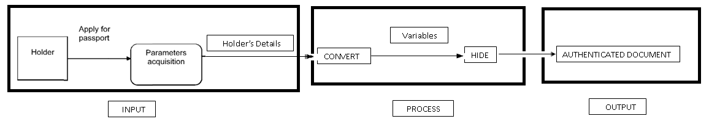

Project Coordinator Head
(Department of Computer Engineering)

